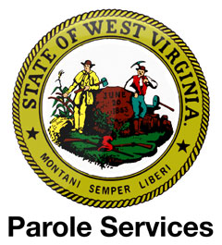
June 23, 2016
Doc.No. 0716-LALR
To: Robert Arnold: Director of Parole Services
Matthew Currence: Supervisor of Northern District
Doug Workman: Supervisor of Southern District
Georgi Watson: Secretary to Director of Parole
1356 Hansford Street Suite B
Charleston, WV 25301
Phone: 304-558-6366
Fax: 304-558-5678

From: Phillip Hudok
RR 1 Box 11
Huttonsville, WV 26273
(304)335-2826
hudok@hudok.com

Dear Gentlemen,

My name is Phillip Hudok. I wish to express my feelings and beliefs concerning my dear friend, Thomas David, House of Deegan OID #3559707:

I have known Thomas for several years and know him to be a man of high Christian morals and convictions. He cares deeply about his fellow man and I have never known Thomas to cause injury to person or property and it is my understanding that he never has.

After 34 trouble free years of life, Thomas admits that he grew pot for medicinal purposes. Thomas has the support of his family and I know from personal experience he has a wide network of friends and supporters not only in the United State, but from around the world.

Because he has never been a threat to society, I humbly and wholeheartedly ask you to grant Thomas’s request for parole.

Sincerely,

Judiciary Courts Of The State Of West Virginia
17th Judicial Circuit
243 High St
Morgantown, WV 26505
(304) 291-7265
Russell Clawges Jr Principal

Executive Office State Of West Virginia
100 Angus East Peyton Drive
Charleston, WV 25303
(800) 520-3852
Ray Earl Tomlin Principal

